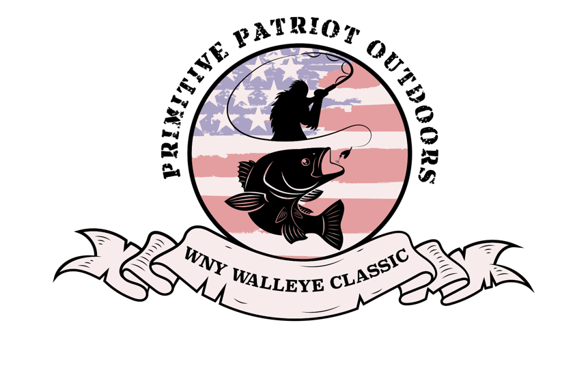
Team Name: Team Captain:
Address: Cell Phone:

In consideration of acceptance of this entry, to participate in the 2024 WNY Walleye Classic.
I, (print) ____________________________for myself, as well as for my participating team members, my heirs, my executors, sponsors, administrators, support groups, fans and any other associates waive, and release absolutely and unconditionally any and all claims that we, we as defined but not limited to the above, may become entitled to for injury or damage, and release the WNY Walleye Classic it’s ownership, officers, directors, all organizing groups, and any other organizers, sponsors, and their active members, servants, agents or employees, from any claims, demands, damages, suits, obligations, actions or causes of actions arising out of any loss, injury or damage to my property incurred while attending at or participating in this tournament, notwithstanding any such loss, injury, or damages which may arise by reason of negligence of any other organizers, sponsors and their respective members, servants, agents, or employees.
In addition, I, individually and for my participating team members also declare that all are aware of the 2024 rules and regulations of the forthcoming tournament. This also includes that I, individually and all participating teammates receiving payments, winnings, prizes from the WNY Walleye Classic are responsible for any/all required state and federal taxes. The WNY Walleye Classic is not accountable for any taxes of any kind paid to recipients.
In addition, by signing this waiver, I also declare that I, individually, have made aware and explained in detail and confirmed with my participating teammates, and with their approval, that they understand the waiver, its contents and the ability of the Teams Master (myself) to sign on their behalf applicable to the forthcoming 2024 WNY Walleye Classic.
Myself and my teammates also fully release and approve, for the WNY Walleye Classic to utilize any/all video, photography and/or audio collected by the tournament Committee and its directors, as we see fit.
Without limiting the generality of the foregoing, I further release any recourse which I and my participating team may now or hereafter have resulting from any decisions of the WNY Walleye Classic and/or organizers, sponsors, and their respective members, servants, agents, or employees.
---------------------------------------------------------------------------------------------------------------------------------------
I confirm I have read this waiver and release and understand its contents, intentions and effect on my legal & equitable rights. I am signing it voluntarily for myself, individually as well as for all members of my participating team; fully releasing the WNY Walleye Classic from any claims.
Team Name (Please Print) ________________________________________
Team Captain Signature ________________________________

